- Introduction

Kerberos

Kerberos is a computer-network Authentication Protocol that works on the basis of Decades to allow nodes Communicating over a non-secure network to prove their identity to one another in a secure manner.

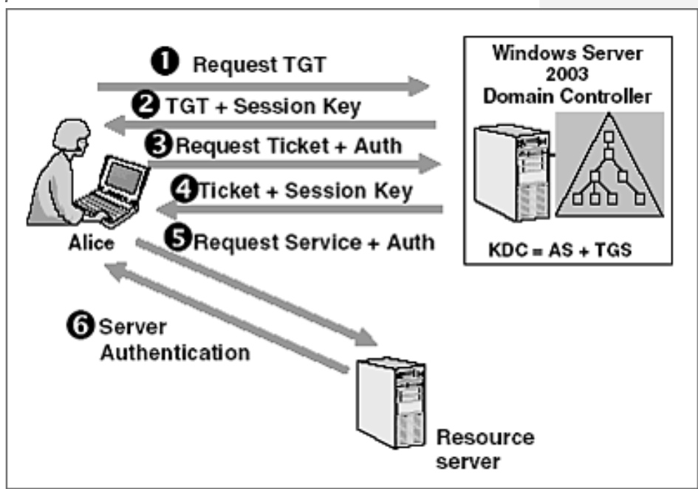

Figure 1: The complete Kerberos protocol.

1.2 who Invented Kerberos?

Massachusetts Institute of Technology (MIT) developed Kerberos to protect network services provided by project Athena.

1.2.1 How does Kerberos protocol Work?
Kerberos is a computer network security protocol that authenticates service request between two or more trusted hosts across an untreested Network like the internet. It uses secret-key cryptography and a trusted third party for authenticating client-server applications and verifying users identities.

    - The 3 main parts of Kerberos?

Kerberos has three parts: a client, server, and treested third party ( KDC) to mediate between them. Clients obtain tickets from the Kerberos key distribution centre (KDC), and they present these tickets to servers when connections are established.

    - What is Kerberos example?

Many UNIX-like operating systems, including Free BSD, Apple's Mac osx, red hat Enterprise Linux 4,sun’s Solaris,IBM's AIX, HP's open VMS, and other, include software for Kerberos authentication of users or services.

    - How is Kerberos used today?

Perhaps the most widely know products which use Kerberos, are Microsoft Windows and Microsoft Active Directory. In a Microsoft network/ domain, users authenticate using the Kerberos protocol when they logon to their Windows workstation.

- CHARACTERISTICS OF KERBEROS

The basic features of Kerberos may be put as:
• It uses symmetric keys.
• Every user has a password.
• Every application server has a passwords.
• The passwords are kept only in the Kerberos database.
• The user given the password only once.

- VERSIONS OF KERBEROS THAT ARE COMMON USE?

Kerberos version 5 is a later version of the Kerberos software came after Kerberos version 4, developed for enhancing security in the authentication. Kerberos version 5 provides a single authentication service in a network which is distributed over an enterprise. It was launched in the year 1993
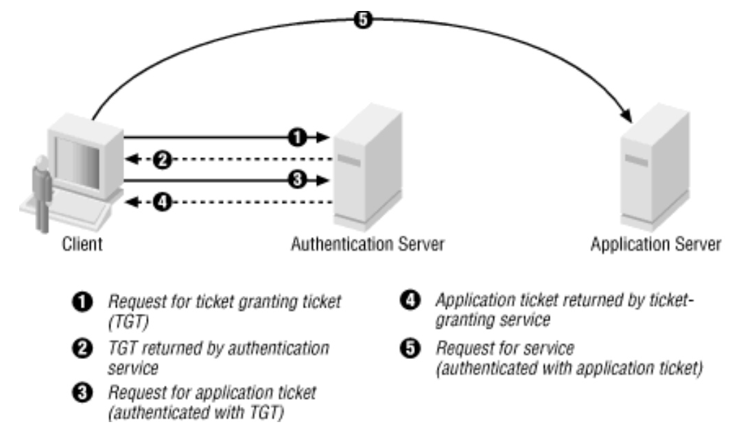

Figure 2: Five step to using the Kerberos protocol.

- HOW IS KERBEROS USED TODAY?
Kerberos is used as the preferred authentication method: in general, joining a client to a Windows domain means enabling Kerberos as the default protocol for authentications from that client to services in the Windows domain and all domains with trust relationships to that domain.

- DIFFERENT SERVERS USED IN KERBEROS?

Both the master KDC server and the slave KDC server create tickets that are used to establish authentication. The realm can also include a Kerberos application server. This server provides access to Kerberos services (such as ftp , telnet , rsh and NFS).

- IS KERBEROS A PROTOCOL ?

Kerberos is an authentication protocol enabling systems and users to prove their identity through a trusted third-party. The protocol was initially developed at the Massachusetts Institute of Technology (MIT) as part of a larger project called Project Athena.

6. Summary and Future Work

In this project I have covered Topics related to Kerberos :

- Kerberos.
- Who invented Kerberos.
- How does Kerberos protocol work.
- The three main parts of the Kerberos.
- What is Kerberos example.
- How is Kerberos use today.
- Characteristics of Kerberos.
- Version of Kerberos are in common use.
- How is Kerberos used today.
- Different servers used in Kerberos.
- Is Kerberos a protocol.

References

https://www.geeksforgeeks.org/kerberos/amp

https://www.simplilearn.com/what-is-kerberos-article/amp

